Pupil premium strategy statement – Kettering Park Infant Academy

This statement details our school’s use of pupil premium funding to help improve the attainment of our disadvantaged pupils.
It outlines our pupil premium strategy, how we intend to spend the funding in this academic year and the outcomes for disadvantaged pupils last academic year.

School overview
Detail | Data
Number of pupils in school | 223
Proportion (%) of pupil premium eligible pupils | 22%
Academic year/years that our current pupil premium strategy plan covers (3-year plans are recommended – you must still publish an updated statement each academic year) | 2024-2027
Date this statement was published | September 2025
Date on which it will be reviewed | September 2026
Statement authorised by | Liam Cox
Pupil premium lead | Mel Eldridge
Governor / Trustee lead

Funding overview
Detail | Amount
Pupil premium funding allocation this academic year | £93,930
Pupil premium funding carried forward from previous years (enter £0 if not applicable) | £0
Total budget for this academic year  If your school is an academy in a trust that pools this funding, state the amount available to your school this academic year | £93,930

Part A: Pupil premium strategy plan

Statement of intent
At Kettering Park Infant Academy, we are committed to ensuring that all children receive the best possible opportunities to achieve their full potential, regardless of their background, circumstances, or any challenges they may face. When making decisions about the allocation of Pupil Premium funding, we carefully consider the context of our school and the specific barriers faced by our disadvantaged pupils. Evidence from the Education Endowment Foundation (EEF) is used to inform our decisions so that funding is directed towards approaches proven to offer the greatest impact and value for money.
Common barriers to learning for disadvantaged children may include reduced support at home, weaker language and communication skills, lower levels of confidence, more frequent behaviour needs, and issues with attendance and punctuality. Some pupils may also experience complex family circumstances which can affect their ability to thrive. These challenges are varied and often interlinked; therefore, a tailored and flexible approach is essential, rather than a “one size fits all” model.

Our aims and objectives are to:
- Ensure all children receive high-quality first teaching in every lesson.
- Narrow the attainment gap between disadvantaged and non-disadvantaged pupils.
- Invest in high-quality CPD for all staff, enabling ongoing reflection, shared practice, and instructional coaching.
- Improve the attendance and punctuality of all pupils.
- Promote consistent teaching and learning approaches that set high expectations and provide appropriate challenge and support for all pupils, including those who are disadvantaged.
- Implement early identification and intervention systems to address gaps in academic progress and social–emotional development promptly.
- Embed a whole-school approach in which all staff take responsibility for the outcomes of disadvantaged pupils.
- Provide high-quality pastoral and wellbeing support to ensure children are safe, happy, and ready to learn.
- Ensure all pupils, regardless of background, are able to meet their potential and access the rich opportunities available at Kettering Park Infant Academy, enabling them to thrive and flourish.

Demographics and School Context
Kettering Park Infant Academy is a three-form-entry infant school and a proud member of the InMAT Trust. The school is located in Northamptonshire in the East Midlands.
We serve a diverse community. Currently:
- 28% of pupils are eligible for Pupil Premium funding
- 16% have Special Educational Needs
- 48% speak English as an Additional Language

The map below displays the Index of Multiple Deprivation (IMD), placing our school community within the 21% most deprived neighbourhoods in England. This context reinforces the importance of targeted, evidence-based use of Pupil Premium funding to reduce inequality and improve outcomes for all pupils.
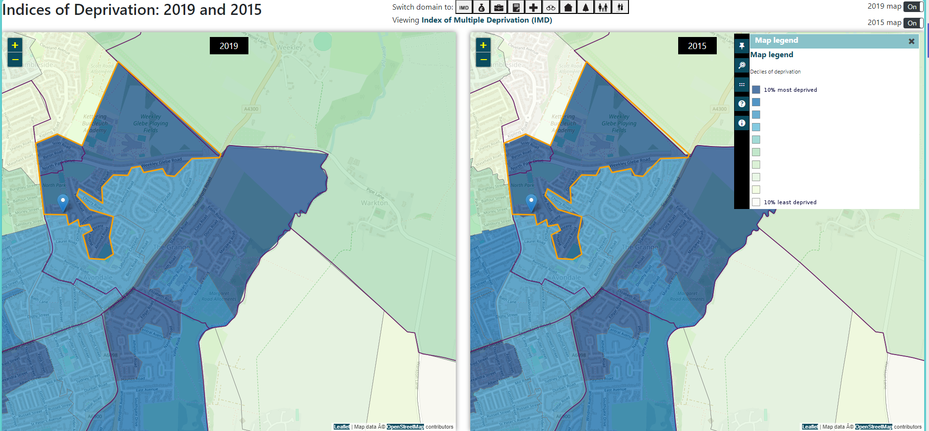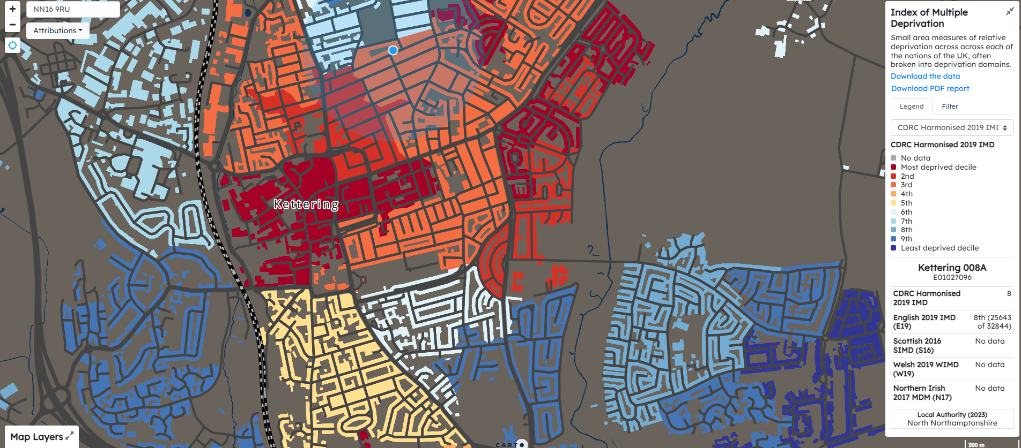

Challenges
This details the key challenges to achievement that we have identified among our disadvantaged pupils.
Challenge number | Detail of challenge
1 | Attainment in reading, writing and maths, with disadvantaged pupils generally achieving below their peers. Assessment indicates gaps in core knowledge, fluency and reasoning skills. There is a risk these gaps widen over time without targeted support, particularly in a context where some pupils have limited access to books, devices or structured learning at home.
2 | Phonics knowledge and application. A significant proportion of disadvantaged children enter school with weaker phonological awareness and slower acquisition of letter–sound correspondences. This impacts decoding, early reading confidence and access to the wider curriculum. Additional intervention is required to secure the application of phonics in independent reading and writing.
3 | Less developed communication and language skills in EYFS and weaker Oracy across Key Stage 1. Many disadvantaged pupils start school with reduced vocabulary, limited expressive language and difficulty articulating ideas clearly. This affects early literacy, social interaction, and the ability to access whole-class teaching and problem-solving activities.
4 | Parental engagement, particularly regarding supporting learning and pastoral needs. A number of disadvantaged families face barriers such as limited availability, confidence, or resources to support reading, homework and wider learning at home. This can affect consistency of routines, emotional regulation, partnerships with school and the ability to reinforce key learning.
5 | Attendance and punctuality. Disadvantaged pupils show higher rates of persistent absence and late arrival. This leads to missed learning, reduced curriculum access, weaker social connections and slower academic progress. Families may face challenges such as transport, health issues, or difficulties with routines, requiring targeted support and early intervention.

Intended outcomes
This explains the outcomes we are aiming for by the end of our current strategy plan, and how we will measure whether they have been achieved.
Intended outcome | Success criteria
To increase the number of disadvantaged (PP) pupils achieving ARE in reading, writing and maths in Key Stage One. | • The percentage of PP pupils achieving ARE is in line with or exceeds the 2023 national average for Reading, Writing and Maths.  • Termly data monitoring and Pupil Progress cycles demonstrate accelerated progress for PP pupils.  • Internal assessments show diminishing gaps between PP pupils and their peers.
To improve phonics knowledge across the school, using Read Write Inc., so that more PP pupils achieve ARE by the end of the year. | • PP pupils make rapid progress in phonics across EYFS and KS1.  • Six-weekly RWI assessments show increased fluency and accuracy in decoding.  • Learning walks verify consistent, high-quality phonics provision across classrooms.
To strengthen communication, language and oracy skills for PP children in EYFS and Key Stage One. | • PP pupils demonstrate improved vocabulary, spoken language and confidence when expressing ideas.  • Observations and assessments show pupils using oracy skills to support reading comprehension and writing outcomes.  • EYFS C&L outcomes for PP pupils improve over the year.
To build a strong support network for PP children and their families, improving engagement with learning and wellbeing. | • PP pupils attend school regularly and punctually, improving access to learning.  • Families with additional needs receive timely support from school or external agencies.  • Increased family participation in school events, meetings and support programmes.
To improve PP attendance so that it is in line with or above national averages. | • Monthly and annual attendance for PP pupils is in line with or exceeds national average.  • The proportion of PP pupils who are persistently absent reduces year-on-year.  • Fewer late arrivals, with improved start-of-day readiness.

Activity in this academic year
This details how we intend to spend our pupil premium funding this academic year to address the challenges listed above.

Teaching (for example, CPD, recruitment and retention)
Budgeted cost: £50,337.03
Activity | Evidence that supports this approach | Challenge number(s) addressed
Training new staff in Read Write Inc. (RWI), with refresher training for existing staff to ensure up-to-date knowledge.  High-quality RWI teaching and coaching programme led by the Phonics Lead.  Regular 6-weekly assessments to review progress and adjust groupings. | Research shows that strong early phonics teaching has a significant impact on early reading development and long-term attainment. Early identification of need is essential.  Use of an accredited, systematic phonics programme aligns with EEF recommendations.  EEF impact: +5 months. | 2
Embedding Quality First Teaching expectations across the school, supported by pupil progress meetings to monitor PP progress and next steps.  Implementing adaptive teaching strategies, including use of Widgits for dual coding.  Using live feedback to maximise progress. | The EEF highlights high-quality teaching as the key driver of improved attainment, particularly for disadvantaged pupils.  Sutton Trust evidence shows Quality First Teaching has the greatest impact on pupil outcomes.  EEF impact: +6 months. | 1, 2
Staff Continuous Professional Development focusing on principles of effective teaching:  – Renewed Teaching & Learning Policy promoting consistent best practice, monitored through learning walks and pupil voice.  – Use of Walkthrus to embed consistent teaching approaches.  – Weekly RWI training for all staff led by the Phonics Lead.  – Updated Marking & Feedback Policy monitored through learning walks, book looks and pupil voice.  – Raising the profile of Oracy and Communication & Language through deliberate vocabulary instruction. | Sustained, high-quality CPD improves teacher practice and leads to better pupil outcomes (EEF).  Ensures disadvantaged pupils receive consistent, high-quality and adaptive teaching across all subjects. | 1 , 2, 3
Weekly Teaching Assistant CPD to develop effective teaching strategies, including approaches for SEND pupils. | The EEF stresses the importance of ongoing professional development for all staff delivering learning. High-quality TA practice improves outcomes when aligned with teacher instruction.  This ensures PP children receive consistent, high-quality support. | 1, 2
Subject leadership network meetings across the Trust to share and model effective practice. | EEF: Modelling provides teachers with high-quality examples that help them understand effective strategies before implementing them. This strengthens subject knowledge and pedagogy across the curriculum. | 1, 2, 3
Whole-school Maths Mastery development using White Rose Maths, ensuring lessons target gaps in knowledge. | The EEF Toolkit identifies mastery learning as highly effective across reading, mathematics and science.  EEF impact: +6 months. | 2
Reading Lead reviewing and enhancing the reading curriculum to ensure clear progression in skills (word reading, vocabulary and fluency).  Use of VIPERS to support explicit teaching and practice of key reading skills. | EF shows that teaching specific reading comprehension strategies (e.g., inference, monitoring comprehension) adds +5 months of progress.  A structured reading curriculum supports consistency and progression. | 2
Coaching for newer or less experienced members of staff through observations and collaboration with experienced teachers. | EF: Effective professional development combines initial training with high-quality follow-on coaching.  Coaching promotes sustained improvements in classroom practice.  EEF impact: +6 months. | 1, 2, 3

Targeted academic support (for example, tutoring, one-to-one support, structured interventions)
Budgeted cost: £17,765.24
Activity | Evidence that supports this approach | Challenge number(s) addressed
TA support in class to support PP children during lessons, enhancing learning and outcomes. | The EEF report Making the Best Use of Teaching Assistants (2015) shows that structured TA support—whether one-to-one or in small groups—can add 3–4 months’ additional progress when aligned to specific learning objectives. | 1, 2, 3
RWI Fast-Track interventions targeting children who are behind in phonics.  One TA delivers Fast-Track support in each year group to raise attainment. | Small group interventions are highly effective for disadvantaged pupils. The EEF Toolkit highlights that focused small-group tuition increases feedback, engagement, and task match to ability, leading to +4 months’ progress. | 3
TA-led small group interventions in maths, reading and writing, focusing on foundational knowledge.  Includes pre-teaching, over-teaching, and post-teaching. Volunteers support reading for children who do not read regularly at home. | The EEF Toolkit indicates small group tuition is effective for closing gaps for disadvantaged pupils because it allows more personalised feedback and sustained engagement. Impact: +4 months’ progress. | 1, 2
Support from external agencies (Educational Psychologist, Blossom Occupational Therapy, School Nursing Team, Maplefields and Rowan Gate Outreach). | EEF evidence shows that teachers and highly trained professionals are the most influential in determining pupil attainment. Professional input and interventions can significantly improve outcomes for disadvantaged pupils, particularly where additional specialist support is required. | 4, 5
Use of PiXL assessments and targeted therapies to identify and address gaps in learning. | Small group and targeted tuition is effective according to the EEF Toolkit. Tailored interventions based on assessment data allow precise feedback and task alignment, supporting +4 months’ progress. | 1, 2, 3

Wider strategies (for example, related to attendance, behaviour, wellbeing)
Budgeted cost: £25,857.73
Activity | Evidence that supports this approach | Challenge number(s) addressed
Family Support Worker employed 2.5 days per week to support vulnerable children and families, including attendance at professional meetings. | EEF: Parental engagement approaches can add an average of 4 months’ progress over a year, with greater impact for pupils with low prior attainment. Supporting pupil regulation can add up to +7 months progress. | 4, 5
Improving attendance through daily tracking, communication with parents, and meetings where attendance concerns arise, in line with the attendance policy. | EEF: Persistent absence is strongly linked to lower attainment and poorer behaviour. Monitoring and intervention strategies to improve attendance are key to raising outcomes. | 5
Use of Pupil Premium funding to support families with trips, school photos, uniforms, and wider experiences. | Social and emotional support and access to enrichment opportunities are linked to better engagement and long-term outcomes. Ensuring all pupils can participate helps mitigate disadvantage. | 4
Use of Pupil Premium funding to enable participation in after-school clubs (e.g., Pacesetters, Mini Me Mindfulness). | EEF and wider research indicate that extracurricular experiences contribute to social, emotional, and cognitive development. Without support, disadvantaged pupils often miss these enrichment opportunities. | 4
Parental engagement initiatives, including:  – Drop-ins  – Phonics sessions  – Reading workshops  – Dojo communication  – Shared reading sessions  – Knowledge organisers  – Home Learning | EEF: Effective parental engagement has an average impact of +4 months’ progress. Engaging all parents prevents widening of attainment gaps and supports learning both at home and in school. | 1, 2, 3, 4, 5

Total budgeted cost: £93,930

Part B: Review of the previous academic year

Outcomes for disadvantaged pupils
2024-2025
Reception outcomes – achieved ELG in Prime areas, Literacy and Maths (GLD – good level of development)
PP | Non PP | National 2024
67% | 67% | 68.3%

Year 1 Phonics Screening
PP | Non PP | National 2023
88.9% | 77.5% | 80%

Year 2 End of Year assessments
 | PP | Non PP | National 2023
Reading | 64% | 61% | 67%
Writing | 36% | 55% | 58%
Maths | 57% | 61% | 68%

Sept 2024-July 2025 Attendance
Whole school attendance – 95.18%
PP attendance = 92.06% Non-PP attendance = 96.32%

Externally provided programmes
Please include the names of any non-DfE programmes that you used your pupil premium to fund in the previous academic year.
Programme | Provider
N/A

Service pupil premium funding (optional)
For schools that receive this funding, you may wish to provide the following information: How our service pupil premium allocation was spent last academic year
N/A
The impact of that spending on service pupil premium eligible pupils
N/A

Further information (optional)
Use this space to provide any further information about your pupil premium strategy. For example, about your strategy planning, implementation and evaluation, or other activity that you are delivering to support disadvantaged pupils that is not dependent on pupil premium funding.

