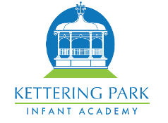

Year 2 – Spring 1 2023


Welcome back to school and Happy New Year! We hope you all have had a lovely Christmas break and had plenty of time to rest and have some fun. We are really looking forward to a new term with lots of exciting things planned.

English – Writing

In our English
lessons this
term, the children
are going to be
writing a
narrative based
on the book ‘George
and the Dragon’ and the film ‘How to train a Dragon.’ We will be focussing on sentence structure and writing for effect. We will be revisiting the use of correct punctuation and tense across a piece of writing.
We will also be writing a non- fiction piece which will be in the form of a diary entry. This will be based on events from The Great Fire of London. Children will take part in experience lessons to stimulate writing ideas. During this unit children will be learning to write in chronological order, use senses such as smell and touch, and also focus on using correct grammar such as exclamation and question marks.

English - Reading

Over the next 3 weeks, year 2 will be reading a fiction book called, The Bear and the Piano by David Litchfield which focusses on the theme of bravery vs. fear.
In our reading sessions, we are continuing to apply phonic knowledge and skills as to decode words decoding. The children will be reading aloud books closely matched to their improving phonic knowledge, sounding out unfamiliar words accurately,
The children will also be drawing on what they already know or on background information and vocabulary provided in class. They will also be making predictions and simple inferences.
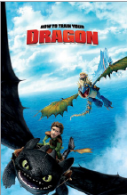

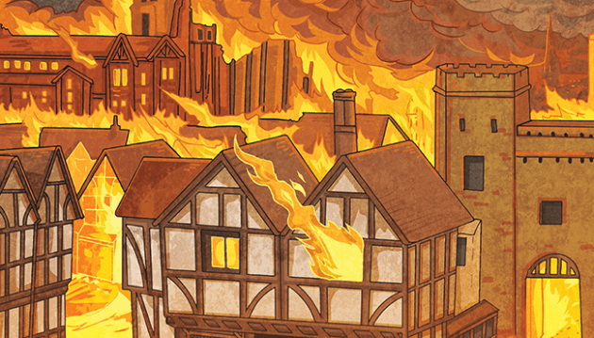
Maths
This term we will be learning about money. There will be a focus on, efficient strategies for counting money, calculating total amounts, finding change and problem solving. We will then move on to multiplication and division. During the unit we will focus on skip counting, equal groups, times-tables and arrays. We encourage children to build their confidence with times-tables by practising 2s, 3s, 5s, and 10s at home regularly. TT Rockstars is a very useful tool to support your child in their learning so please remember to allow your child to use this as home. In addition we will continue using Maths Whizz at school and also encourage children to access this resource online at home regularly to support learning.

History
In History, we are learning all about the Great Fire of London this term. We will be starting by looking at London and how it has changed over the years and also starting with a WOW lesson where we look at how the Tudor houses burnt so quickly. Children will be learning about Samuel Pepys, a key historical figure from this event and looking at the diary he wrote.
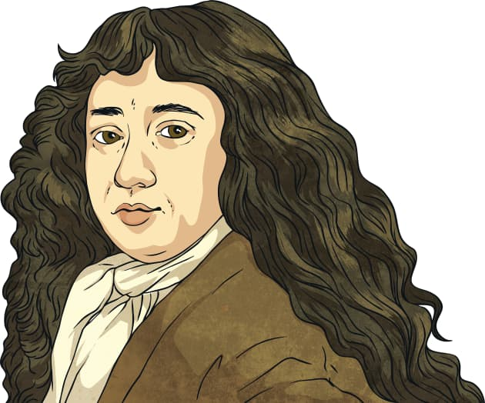

Science
This term in Science, we are learning about habitats and how different animals adapt to their environments. We will also be learning about microhabitats and going on a hunt for mini-beasts in their microhabitats. We will also be learning about how plants and animals rely on each other in their environments as well as how to tell if something is living, no longer living or never lived.


Art
This term in Art the children will be creating their own sculptures using clay techniques. Their sculpture will be based on the work of Henry Moore. They will design, make and evaluate their sculpture thinking about how they could improve their work and what they thought worked well.
RE
This term in RE, we are learning about Islam and why prayer is so important for Muslims. We will be looking at why they are committed to praying five times each day and discuss how this might be difficult to do. We will also learn about how prayer keeps them calm and supports them in reaching their goals. Then we will be reflecting on our own personal goals and how we can achieve these.
Other useful information
PE – Our PE days this term are…
Class 7 and 8 – Friday
Class 9 – Tuesday
Please ensure that earrings are removed on PE days and PE kit is brought into school to remain on their peg for the term.
Websites –
https://play.ttrockstars.com/
https://www.oxfordowl.co.uk/
https://www.whizz.com/
Computing
This term for Computing Year 2 will be learning about robot algorithms. Children will begin to understand instructions in sequences and the use of logical reasoning to predict outcomes. Children will also be learning about design in programming and have the opportunity to design their own algorithms and test these.

