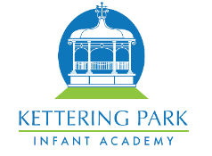

Year 1 – Autumn 2 2022


We have had a fantastic first term in Year 1 and look forward to the next term ahead. We have planned some fantastic lessons, which are detailed below.

English - Writing
In our English
lessons this
term, the
children are
going to learn
how to write a
non-fiction report about old toys. We will be looking at headings and subheadings and how these can section out what we are writing. We will also be focussing on questions, learning the correct vocabulary for question starters and using question marks at the end.
We will also be writing a narrative based around Oliver Jeffers’ story ‘The Way Back Home.’ Whilst working through the story, we will continue to focus on sentence structure including capital letters and full stops. We will also be looking at checking our work to make sure it is
written
correctly and
makes sense.

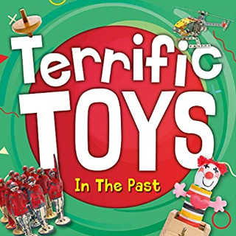
English - Reading
For our reading this term, we will be building up our reading comprehension skills, retrieving key aspects from the text ‘Billy and the Beast’.
We will be making
predictions
based on what
we have read
so far. The
children will also
sequence the
events of the story and give opinions on their views of the characters and story line.

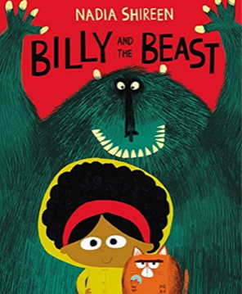

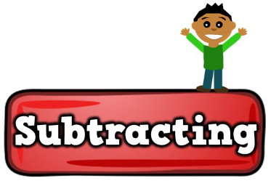
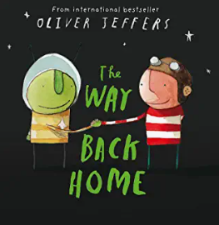
Maths
In our maths this term we will be learning how to subtract numbers within 10. This will include crossing out and physically removing objects and counting how many are left. We will be learning to differentiate between the number they begin with, the
number taken
away and the
number left.

We will also be learning about 2D and 3D shapes and identifying them from their properties.
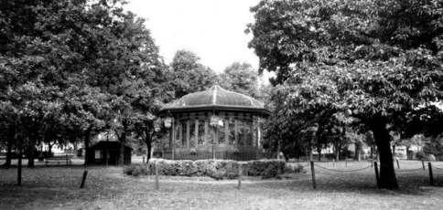
History
We will be
continuing
to learn the
about the
past with a particular focus on the pleasure park, which was built in 1884. The children will identify what is the same and what has changed over time. We will also be learning about key parts of Kettering, particularly the changes to the market square and how this has changed over time.
Science
This term, we will be learning about everyday materials including wood, plastic, metal, stone, glass and water. We will be learning about the properties of each material including opaque/ transparent and absorbent/ waterproof and completing scientific investigations to find these out. The children
will learn the
difference between
objects and
materials.

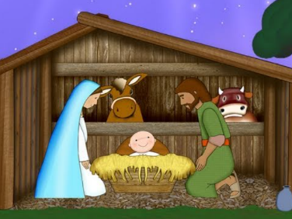
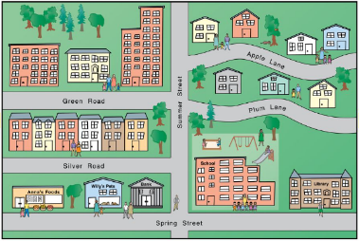
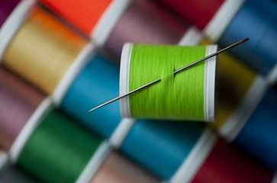
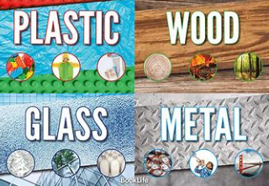
RE
This term, we will be looking at the Christian’s Christmas story and make a decision on what gifts would be meaningful to Jesus. The children will be linking special gifts from their own experiences and linking this to the gifts Jesus received. We will also be making story stick characters using a range of collage
materials and
using these to
retell the
Christmas story.
Other useful information
PE – Our PE days this term are… Class 4 and 5 – Thursday
Class 6 – Monday
Please ensure that earrings are removed on PE days and PE kit is brought into school to remain on their peg for the term.
Websites –
https://play.ttrockstars.com/
https://www.oxfordowl.co.uk/
https://www.ictgames.com/

Geography
We are going to continue to learn about maps, looking into aerial views, key features including symbols and keys and what is located around the pleasure park.
This will allow the children to
then create their own maps,
which people
can use to help
them locate key
areas.
DT
We are going to be
learning how to
create a glove puppet.
This will involve investigating how they are put together and what the correct size would be. The children will have the opportunity to design, make and evaluate their own hand puppet and testing this out in a puppet show. During the making stage, we will be learning how to thread a needle and stitch fabric together.

