

Year 1 – Spring 1 - 2023


We would like to start by saying a HUGE well done to the efforts your child put in last term. We hope they have had a wonderful Christmas break and are well rested, ready to start their next lot of learning this term.

English - Writing
In our English lessons this term, we will be
continuing our
sentence
structure writing
based on the
story ‘Wombat
Goes Walkabout.’
The children will be using capital letters, finger spaces and the correct punctuation in their sentences, including full stop, question and exclamation marks. They will also be working carefully on their handwriting to make it smaller, on the lines and similar in letter size. They will also be exploring adjectives and using them to describe the character and story settings. They will be exploring the actions of the characters as well as how they feel at certain points in the story. The children will be learning the structure of a story too and exploring story highs and lows. This will then help them when writing their own narrative.

English – Reading
In our reading sessions, the children will be reading a story called ‘Beegu’, which is about an alien who gets lost. This story supports the children to use their phonic knowledge to read both real and nonsense words. They will also be making predictions as to what happens to Beegu in
the end and
sequencing the story
once they are really
familiar with it.

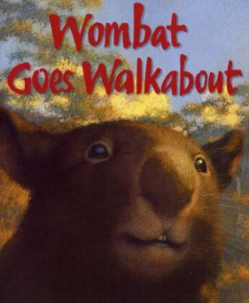

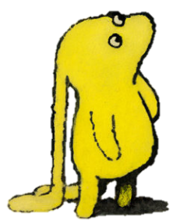

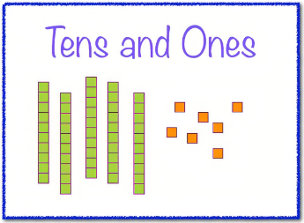
Maths
Our maths unit this term is using our addition knowledge to work with numbers up to 20. The children will be counting using 10s and 1s, finding one more and one less of a given number, comparing a number of objects saying which is greater and less and comparing and ordering numbers. This unit will consolidate what
we have already
learnt from last
term and build
upon this.
Art
During our art lessons, the children will be learning about sculpture in both natural and man-made form. This will be done through both artists Barbara Hepworth and Andy Goldsworthy. The children will be using natural materials to create a piece of art before using clay to create their own 3D sculpture.
Science
In our science we will be learning about animals and sorting them into their groups. We will be exploring similarities and differences between them, where they live and naming key features that we can see. We will be learning
what animals
eat and whether
they are
carnivores,
herbivores or
omnivores.

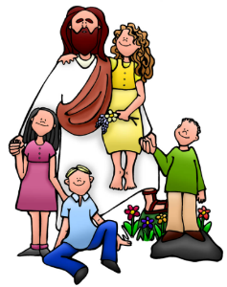
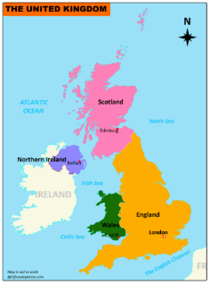
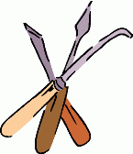
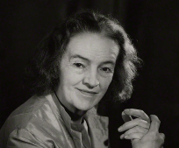
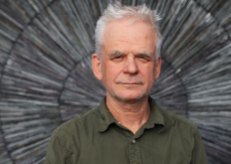
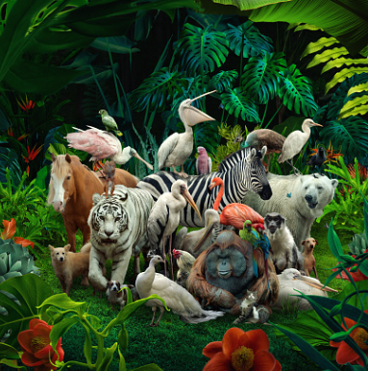
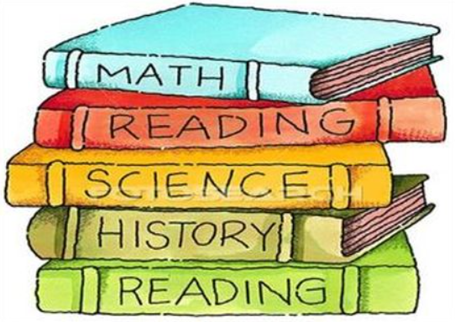
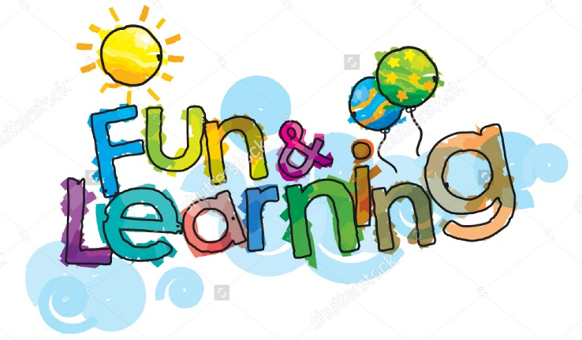
RE
During our RE unit, the children will be exploring what makes a good friend and how Jesus was a good friend to others. The children will be able to reflect on a range of stories from the bible to understand the feelings of different people and what actions people used to help others. We will be learning how to be friends with
others even in
difficult situations
and how Jesus
managed this too.
Other useful information
PE – Our PE days this term are… Class 4 and 5 – Thursday
Class 6 – Monday
Please ensure that earrings are removed on PE days and PE kit is brought into school to remain on their peg for the term.
Websites –
https://play.ttrockstars.com/
https://www.oxfordowl.co.uk/
https://www.ictgames.com/

Geography
In our geography lessons, the children will be learning about the United Kingdom The children will be able to identify the four countries, their capital cities and some main landmarks within each of these. The children will also be
able to name the three
main seas around the
UK including the
Atlantic sea, the
North Sea and the
Channel.

