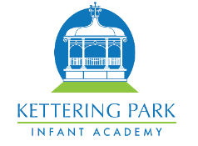

Reception – Summer 1 2023


We look forward to the next term ahead and have planned some fantastic learning, which is detailed below.

Personal, Social and Emotional Development

This term our Jigsaw unit is called ‘Relationships’.

In this Puzzle Children are introduced to the key relationships in their lives. They learn about families and the different roles people can have in a family. They explore the friendships they have and what makes a good friend. They are introduced to simple strategies they can use to mend friendships. The children also learn about Jigsaw’s Calm Me and how they can use this when feeling upset or angry.

Communication and Language This term we will be following unit plans for the story ‘Jack and the Jelly Bean Stalk.’ The children will be introduced to key plot points from the story, alongside rich vocabulary that they will be supported to use in their speech and writing. For example, “Jack was broken hearted that he had to sell his cow.” We will be learning to re tell this story as well as another one of our key story texts ‘The Three Billy Goats Gruff’.

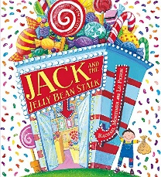
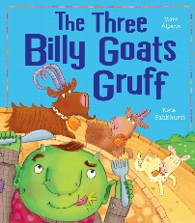

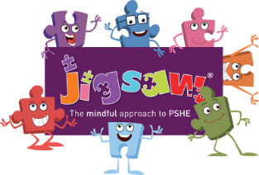
Physical Development
In this unit children will develop their ball skills through the topic of 'weather'. They will:

-Develop fundamental ball skills such as throwing and catching, rolling a ball, using targets, dribbling with feet, kicking a ball, bouncing and catching a ball.

-Be able to develop their fine and gross motor skills though a range of game play with balls.

-Work independently and with a partner and will develop decision making and using simple tactics.

Other useful information
PE – Our PE day this term is a Wednesday. Please ensure that earrings are removed on PE days and PE kit is brought into school to remain on their peg for the term.
Websites -
https://www.oxfordowl.co.uk/
https://numbots.com/

Literacy-Reading
As part of our reading curriculum this term,
we will be exploring the text ‘’Hairy Maclary” and using prediction skills, drama to think about the characters. We will also be exploring the book ‘The Night Pirates’ and
the children will be
asked to carefully
consider questions,
such as ‘Were the Night
Pirates good pirates?’

Literacy-Writing
As part of our writing curriculum this term, the children will develop their skills writing sentences using capital letters and full stops linked to our story text ‘Jack and the Jelly Bean Stalk’. The children will continue to learn about story structure with our second writing text ‘The Three Billy Goats Gruff’ where they will write about each key plot point.

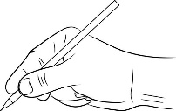
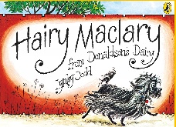



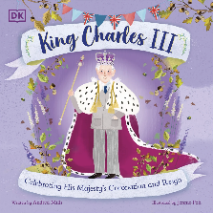
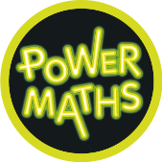
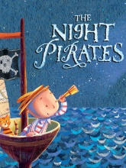
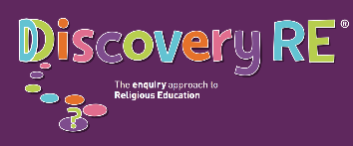
Expressive Arts and Design
This term the children will continue to develop their
artistic skills by exploring materials and techniques to
create a ‘Jelly Beanstalk.’ They
will be set a challenge to design a bridge for the three billy goats, thinking about function.
Within music the children will…
-listen to ‘Funk’ music each week. -Use voices and classroom instruments

Understanding the World
This term the children will learn about Summer and compare this season to Spring. Through story settings we will discuss different environments.

They will learn about
the past e.g. different
toys, clothes using
photos and objects,
which will lead into some learning about the Royal family and the coronation of King Charles III.

They will develop their knowledge about growth, planting their own seed and observing the life cycle of a butterfly.

The children will also have the opportunity to share old photos of how they and their family have changed linked to our learning about ‘Past and Present’

Maths
This term the children will
be taught to:

-Add by counting on and take away by counting back.
-Count to and from 20.
-Continue to recognise the pattern of the counting system.
-Distribute quantities equally.
-Recognise patterns within numbers to 10-evens and odds, double facts.

RE
This term in RE, the theme is ‘stories’. Children will be introduced to different stories linked to the religions: Christianity, Islam, Hinduism, Sikhism and consider… What we can learn from stories?



