

Reception –Spring 1 2023


We look forward to the next term ahead and have planned some fantastic learning, which is detailed below.

Personal, Social and Emotional Development
This term our Jigsaw unit is called ‘Dreams and Goals’.

In this Puzzle the children talk about challenges and facing up to them. They discuss not giving up and trying until they have achieved their goal. The children are encouraged to think about jobs that they might like to have when they are older and are taught to associate what they learn now with being able to have the job they want. They also talk about achieving goals and the feelings linked to this.

Communication and Language
This term we will be following unit plans for the story ‘Handa’s Surprise’. The children will be introduced to key plot points from the story, alongside rich vocabulary that they will be supported
to use in their
speech and writing. For
example,
“She can smell
delicious fruit.”

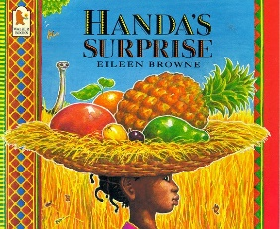

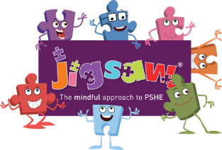

Physical Development
In this unit, children will develop their basic gymnastic skills through the topic of 'traditional tales'. Children explore basic movements, creating shapes and balances, jumps and rolls. They begin to develop an awareness of space and how to use it safely. They perform basic skills on both floor and apparatus. They copy, create, remember and repeat short sequences. They begin to understand using levels and directions when travelling and balancing.

Other useful information
PE – Our PE day this term is a Wednesday. Please ensure that earrings are removed on PE days and PE kit is brought into school to remain on their peg for the term.
Websites -
https://www.oxfordowl.co.uk/
https://numbots.com/

Literacy-Reading
As part of our reading curriculum this term, we will be exploring the text ‘Super Milly’ and be considering what a super power is. We will also be exploring the book ‘The Magic Paintbrush’. Children will be encouraged to imagine what they would paint with it.
Literacy-Writing
As part of our writing curriculum this term, the children will develop their skills writing words and sentences linked to our story text. ‘Handa’s Surprise’ We will be focussing on applying sound knowledge to spell independently and sentence skills, such as using finger spaces and re-reading.


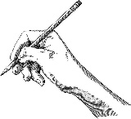

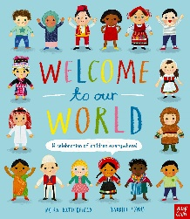

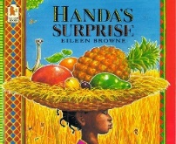
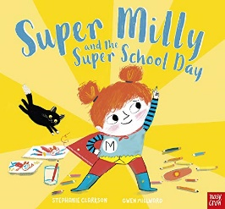
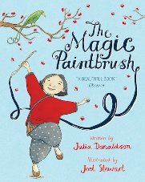
Expressive Arts and Design
This term the children will all learn to use observational drawing skills to sketch some of the fruit seen in the story ‘Handa’s Surprise’.
The children will
continue to have
free access to resources to work on their own artistic projects

They will listen and respond to a variety of music from around the world.

Understanding the World
This term the children will learn about the world and life in other countries. Using books, photographs, google
earth and the sharing
of their own
experiences, they will
learn to recognise some similarities and differences between life in this
country and life in other countries.

Maths
This term the children will be taught to:

-Use positional and directional language.
-Recognise, represent and manipulate numbers to 10.
-Practise the skill of comparing groups of objects up to 10.
-Combine two groups to find a whole up to 10.
-The difference between measuring weight and size through investigation.

RE
This term in RE, the children will be learning about ‘Celebrations’ and how people celebrate. They will learn about how New Year can be celebrated with a focus on Chinese New Year and the Persian New Year. Finally they will learn about Holi ‘The Hindu Festival of colour’.

